**DAILY ONLINE ACTIVITIES SUMMARY**

|  |  |  |  |  |  |  |  |  |
| --- | --- | --- | --- | --- | --- | --- | --- | --- |
| **Date:** | **20 may 2020** | | | | | **Name:** | **Keertana Ganesh Ganiga** | |
| **Sem & Sec** | **4th sem, 2nd year** | | | | | **USN:** | **4al18cs036** | |
| **Online Test Summary** | | | | | | | | |
| **Subject** | | **OBJECT ORIENTED CONCEPTS (18cs45)** | | | | | | |
| **Max. Marks** | | **30** | | **Score** | | | **19** | |
| **Certification Course Summary** | | | | | | | | |
| **Course** | **Java Programing** | | | | | | | |
| **Certificate Provider** | | | **great learning** | | **Duration** | | | **5 hours** |
| **Coding Challenges** | | | | | | | | |
| **Problem Statement:4 program** | | | | | | | | |
| **Status: Executed** | | | | | | | | |
| **Uploaded the report in Github** | | | | | **Yes** | | | |
| **If yes Repository name** | | | | | <https://github.com/keertanaganiga/Lockdown_coding> | | | |
| **Uploaded the report in slack** | | | | | **Yes** | | | |

**Online Test Summary:**

Today OBJECT ORIENTED CONCEPTS was conducted of first module. Total marks for the test was 30.The online test conducted includes MCQ kind questions and also output prediction.

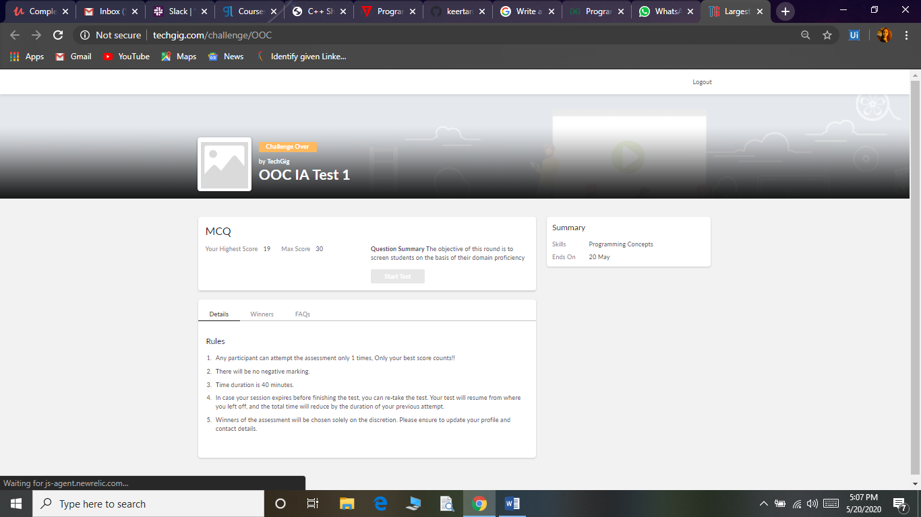

**Certification Course Summary:**

Today I started new certificate course through Great learning. I choose the concept of Java programming. I learnt about Agenda, what is java, Installing of java and java IDK, First java program, Variables and Data types, Operators in java, Flow Control Statements in java.

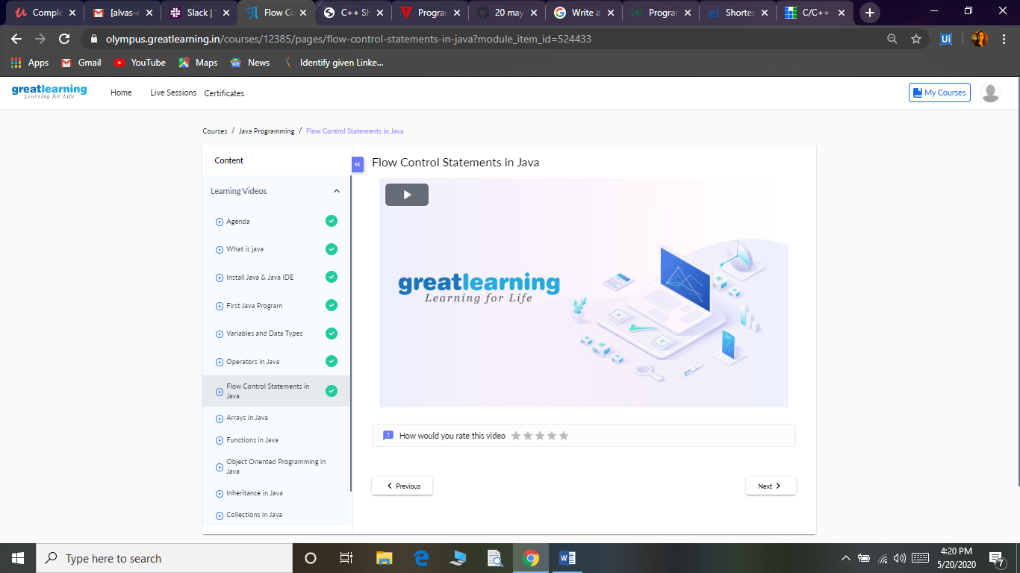

**Coding Challenges:**

Today I solved 4 coding challenge,

1.Related to linked list:

Test Case 1:

If a linked list is: 1 → 2 → 3 → 4 → 5 → 6 → 7 → 8

The value of size k is 2

Then the linked list looks like: 2 → 1 → 4 → 3 → 6 → 5 → 8 → 7

Test Case 2:

If a linked list is: 1 → 2 → 3 → 4 → 5 → 6 → 7 → 8

The value of size k is 3

Then the linked list looks like: 3 → 2 → 1 → 6 → 5 → 4 → 8 → 7

2. program print Duplicates which prints the duplicate elements of the given array:

Given an array a[] of size n which contains elements from 0 to n-1, write a program print Duplicates which prints the duplicate elements of the given array. If no duplicate element is found print -1.

Input:

The first line of input must contain an integer n which denotes number of elements of Array. Second line contains n space separated integers denoting elements of array a[].

Output:

Print the duplicate elements from the given array.

3. **First come First Served related and Shortest Job First related:**

**Write a C or Java program to implement FCFS and SJF process scheduling.  
Input: Processes with burst time  
Output: Process being scheduled**

